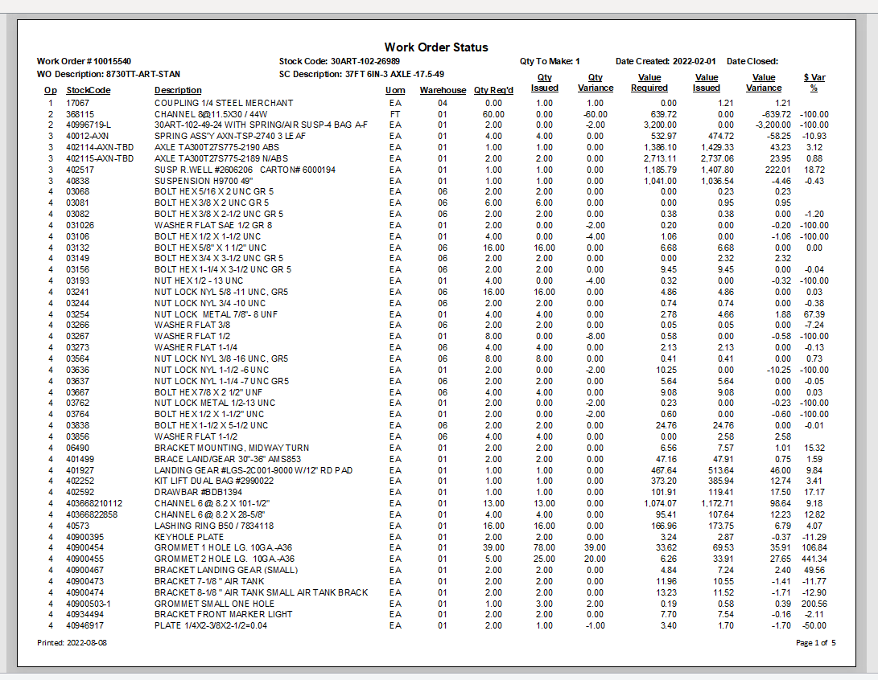
Difference between the amount that was predicted for the unit and what was used.
Qty manufacturing have used to the workorder.
Qty then Eng./BOM believe the workorder required.
Default warehouse.

Part number.
Operation the part is required for.
Stocking unit of measure.
Item description in short.

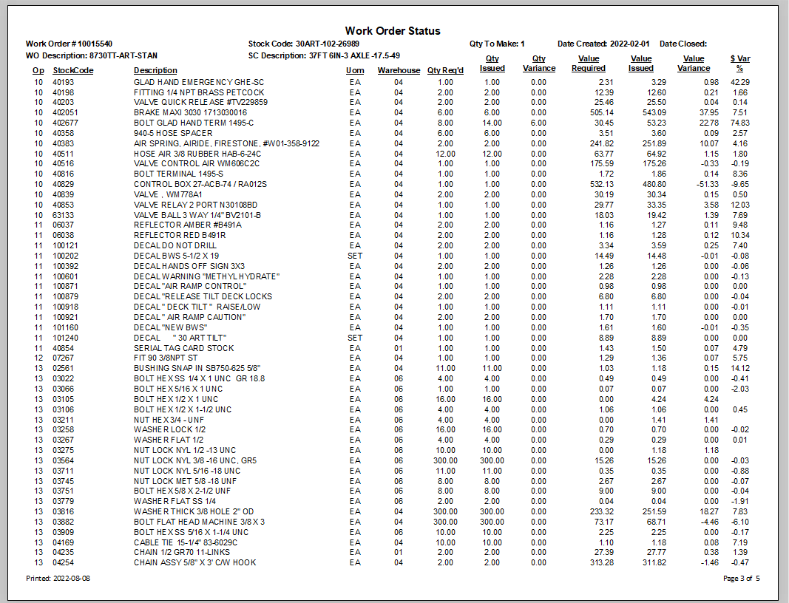
Dollar value required (when part was added on).
Dollar value issued (when part was added on).

